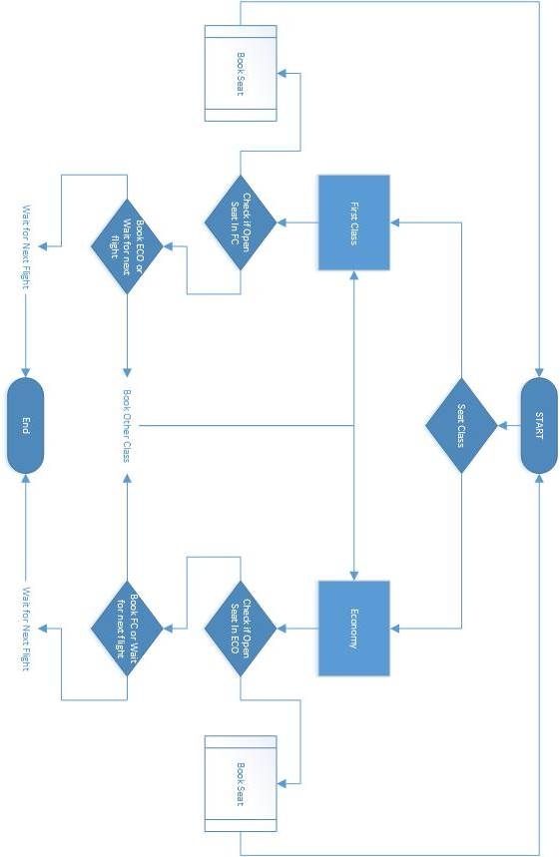

Main Functionality:

|  |  |  |  |
| --- | --- | --- | --- |
| Complete? | Requirement | Date Completed | Date Tested |
| x | Uses one dimensional Boolean array | 4/18/18 | 4/20/18 |
| x | Has First(Seats 1-5) and Economy(Seats 6-10) classes | 4/18/18 | 4/20/18 |
| x | Provides Boarding Pass | 4/19/18 | 4/20/18 |
| x | If a class is full, offer other class | 4/18/18 | 4/20/18 |
| x | If plane is full, “Next flight leaves in 3 hours” | 4/18/18 | 4/20/18 |
| x | Cannot assigns seats previously assigned | 4/18/18 | 4/20/18 |

Improvements:

|  |  |  |  |
| --- | --- | --- | --- |
| Completed? | Potential Improvement | Notes | Date Completed |
| x | Available seating display | Implemented | 4/19/18 |
| x | Printable Boarding Pass | Prints boarding pass | 4/19/18 |
|  | One page application | Chose to use multiple forms for ease of use |  |